Name: Mohammad Awais
Class: BSCS-8-A
CMS: 242554

Compiler Construction Lab 1

Task 1
Regular Expression: a(bb)*bc

Part A ) DFA
S0
S1
S4
S2
S3
a
b
b
c
b,c
a, b, c
a,c
a
a, b, c

Part B ) Language
A language that starts with ‘a’ and ends with ‘c’ and have only odd number of ‘b’s between them.

Part C ) Code Implementation in C++ (i)

(ii) Goto
#include <iostream>
using namespace std;

int main() {
string str;

cout << "Enter a String: ";
cin >> str;

// Validation of ALphabet
for (char c : str){
if (c != 'a' && c!= 'b' && c!='c'){
cout << "[-] Input string is invalid ( i.e. doesn't belong to {a,b,c} )\n\n";
return 0;
}
}

// GOTO implementation
int i = 0;
s0:
if (str[i] == 'a'){
i++;
}
else if(str[i] == 'b' || str[i] == 'c'){
goto s4;
}
s1:
if (str[i] == 'b'){
i++;
}
else if(str[i] == 'a' || str[i] == 'c'){
goto s4;
}

s2:
if (str[i] == 'c'){
i++;
}
else if(str[i] == 'b'){
i++;
goto s1;
}
else if(str[i] == 'a'){
goto s4;
}

s3: // State Final
if (str.length() == i){
cout << "[+]Your entered string '" << str << "' is acceptable\n\n";
return 1;
}
s4: //Garbage state
cout << "[-]Your entered string '" << str << "' is unacceptable\n\n";
return 0;
}

(ii) Switch Statement
#include <iostream>
using namespace std;

int main() {
string str;

cout << "Enter a String: ";
cin >> str;

// Validation of ALphabet
for (char c : str){
if (c != 'a' && c!= 'b' && c!='c'){
cout << "[-] Input string is invalid ( i.e. doesn't belong to {a,b,c} )\n\n";
return 0;
}
}

// Switch implementation
int state = 0;

for (char c : str){
switch(state){
case 0:{
switch(c){
case 'a':{
state = 1;
break;
}
default:{
state = 4;
break;
}
}
break;
}
case 1:{
switch(c){
case 'b':{
state = 2;
break;
}
default:{
state = 4;
break;
}
}
break;
}
case 2:{
switch(c){
case 'c':{
state=3;
break;
}
case 'b':{
state = 1;
break;
}
default:{
state = 4;
break;
}
}
break;
}
case 3:{
switch(c){
case 'a':
case 'b':
case 'c':{
state = 4;
break;
}
}
break;
}
}
}
switch(state){
case 3:{
cout << "[+]Your entered string '" << str << "' is acceptable\n\n";
return 1;
}
default:{
cout << "[-]Your entered string '" << str << "' is unacceptable\n\n";
return 0;
}
}
}

Part D ) Testing Implementation

(ii) Goto
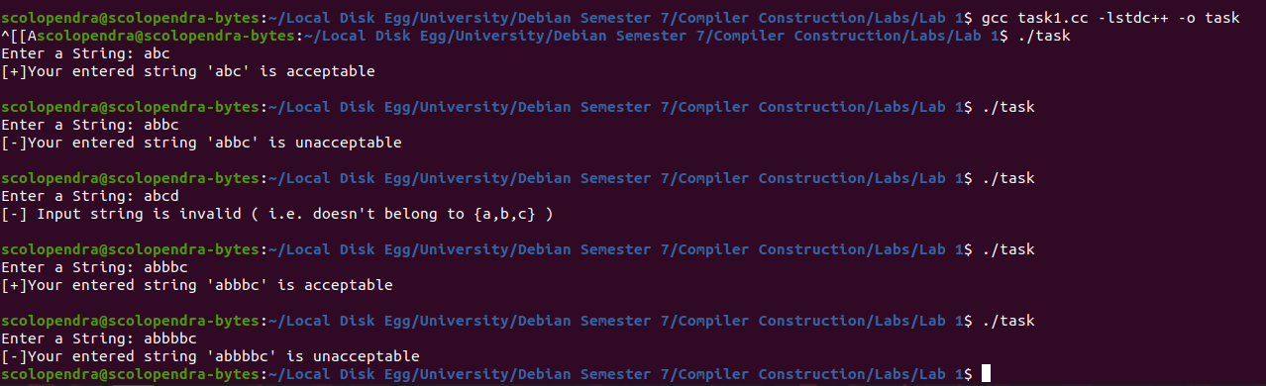

(ii) Switch
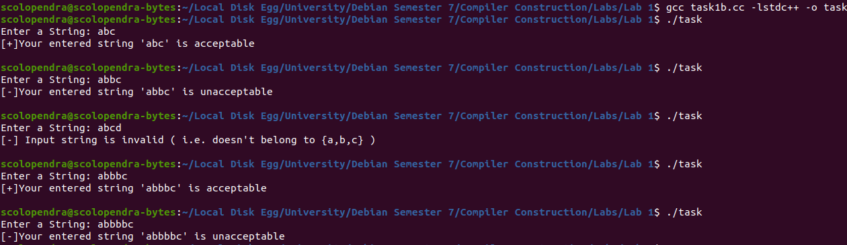

Task 2
L(M) = {w | w € {a, b}* and contains even number of a’s and b’s}

Part A ) DFA
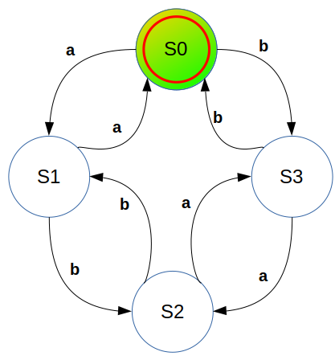

Part B ) Code Implementation in C++ (i)

(ii) Goto
#include <iostream>
using namespace std;

int main() {
string str = "";

cout << "Enter a String: ";
getline(cin,str);

// Validation of ALphabet
for (char c : str){
if (c != 'a' && c!= 'b'){
cout << "[-] Input string is invalid ( i.e. doesn't belong to {a,b} )\n\n";
return 0;
}
}

// GOTO implementation
int i = 0;
s0:
if (str[i] == 'a'){
i++;
}
else if (str[i] == 'b'){
i++;
goto s3;
}
else if (str.length() == i){
cout << "[+]Your entered string '" << str << "' is acceptable\n\n";
return 1;
}
s1:
if (str[i] == 'b'){
i++;
}
else if(str[i] =='a'){
i++;
goto s0;
}

s2:
if (str[i] == 'a'){
i++;
}
else if(str[i] == 'b'){
i++;
goto s1;
}

s3: // State Final
if (str[i] == 'a'){
i++;
goto s2;
}
else if(str[i] == 'b'){
i++;
goto s0;
}
cout << "[-]Your entered string '" << str << "' is unacceptable\n\n";
return 0;
}

(iii) Switch
#include <iostream>
using namespace std;

int main() {
string str = "";

cout << "Enter a String: ";
getline(cin,str);

// Validation of ALphabet
for (char c : str){
if (c != 'a' && c!= 'b'){
cout << "[-] Input string is invalid ( i.e. doesn't belong to {a,b} )\n\n";
return 0;
}
}

// Switch implementation
int state = 0;

for (char c : str){
switch(state){
case 0:{
switch(c){
case 'a':{
state = 1;
break;
}
case 'b':{
state = 3;
break;
}
}
break;
}
case 1:{
switch(c){
case 'a':{
state = 0;
break;
}
case 'b':{
state = 2;
break;
}
}
break;
}
case 2:{
switch(c){
case 'a':{
state=3;
break;
}
case 'b':{
state = 1;
break;
}
}
break;
}
case 3:{
switch(c){
case 'a':{
state = 2;
break;
}
case 'b':{
state = 0;
}
}
break;
}
}
}
switch(state){
case 0:{
cout << "[+]Your entered string '" << str << "' is acceptable\n\n";
return 1;
}
default:{
cout << "[-]Your entered string '" << str << "' is unacceptable\n\n";
return 0;
}
}
}

Part C ) Testing Implementation

(i) Goto
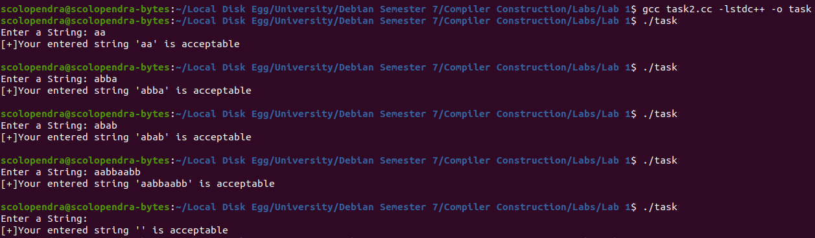

(ii) Switch
